HTML Assignment 4 - Band Albums Website - /20

(part of the Client Side Scripting Credit)

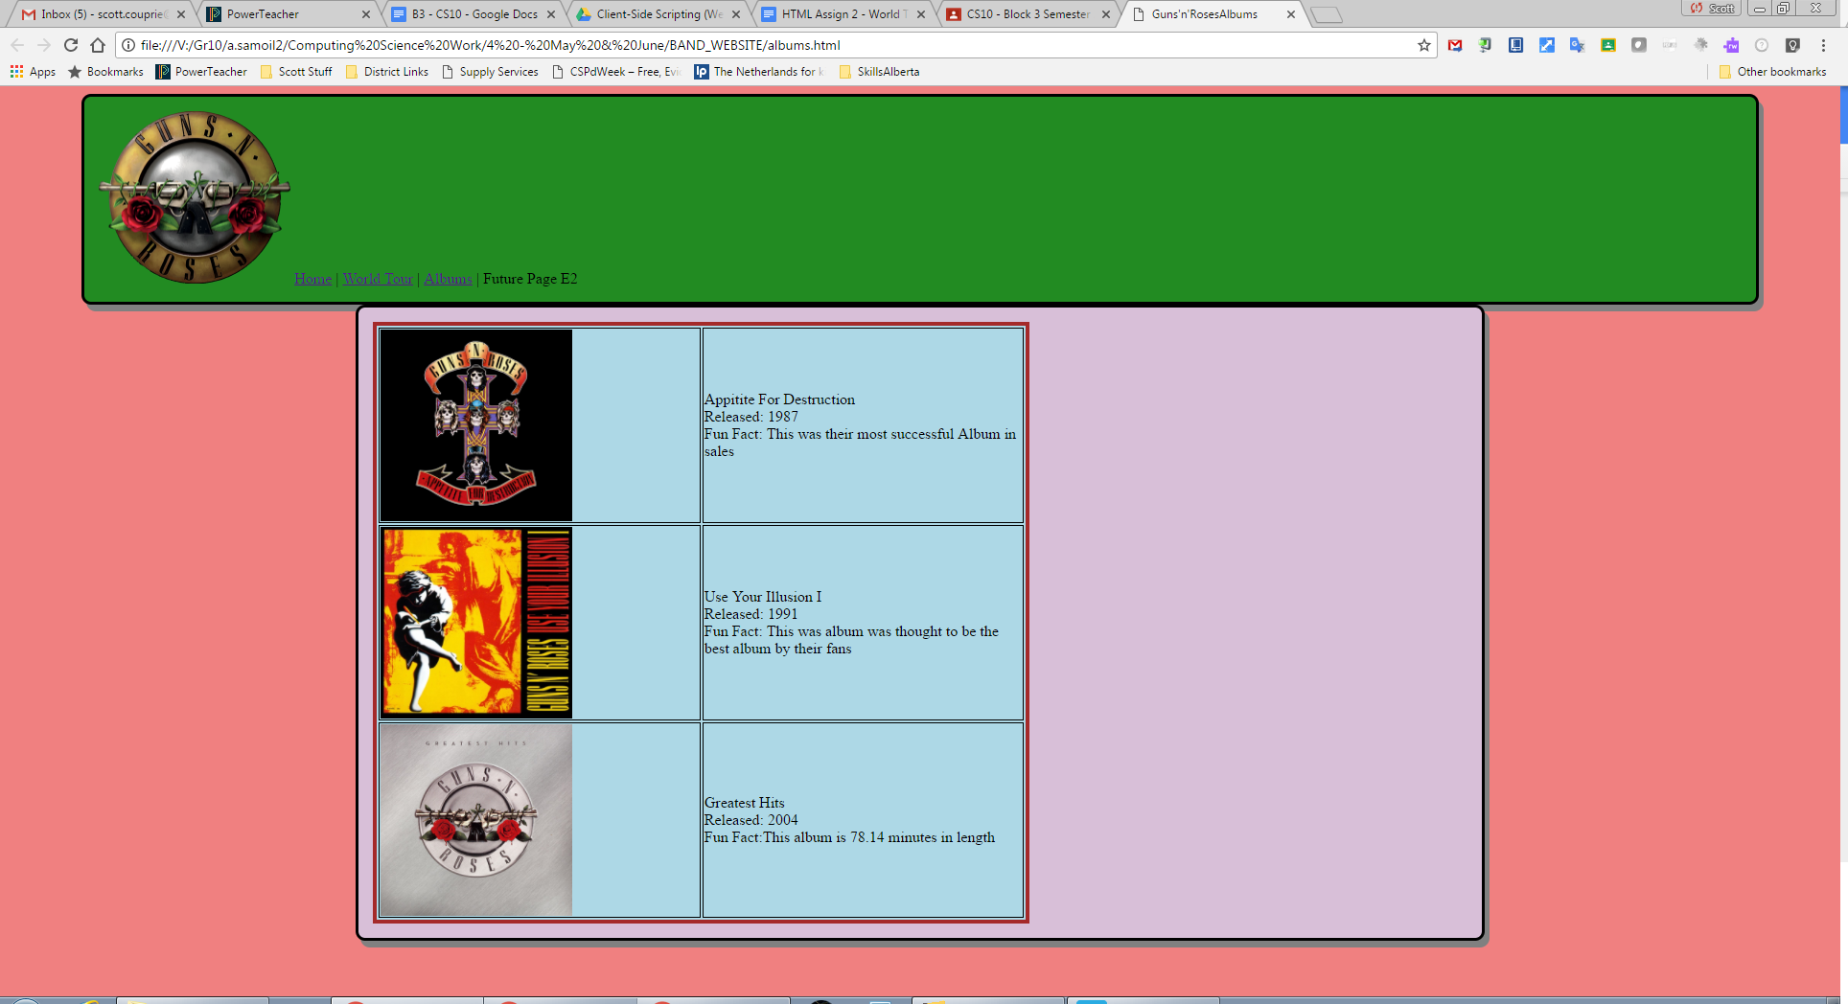

**Important Note: this picture does not match your assignment. It is similar but not exactly the same.**

Tips/Reminders

| Using IDs  #weather { }  <div id=”weather”> | IDs are generally used for a single use only. That is, each person only has a unique ID number. |
| --- | --- |
| Using Classes  .quotes { }  <p class=”quotes”> | Classes are generally used when you will have many of the same type. In a long essay, you may want many paragraphs styled with indenting, italics, etc and would therefore create a class called quotes. |

File Setup:

* Save a new file as albums.html into your BAND_WEBSITE folder
* If you used an external .css style sheet in assignment 2, set up this page to use the same css file.

In the HTML File

Give this page the same background color as the previous page. **- /2**

Copy the navigation bar div from assignment 2 and update the links on all the pages to include this new page. **- /3**

Give this div the ID *navbar*. **- /1**

In the .css file or style code: **- /1**

* set the width of the navbar ID to be 90%. #navbar{ }

Main Content Div **- /5**

Set up a second div below the first one.

Give this div the ID *maincontent*.

In the .css file or style code add the maincontent ID and give it the following settings:

* set the width to be 60%.
* a new but complementary background color.
* Padding of 20 pixels.
* Border color with optional border radius and shadow.

Basic Table **- /4** (3 albums, in a table, with pictures, and text)

Start by pasting the following tags into your Main Content Div. It will set up a 3 row, 2 column table. Delete the words in the table once you have everything working.

<table>

<tr> <td>TYPES OF LAYOUT</td> <td>EASY?</td> </tr>

<tr> <td> Div Tags</td> <td>yes</td> </tr>

<tr> <td>Table tags</td> <td>no</td></tr>

</table>

Once the table is set up and working:

* In column 1, add a picture of an album - preferably, choose a square picture and use HTML to make it about 300px wide (or something similar that looks good).
* In column 2, add the title and the released date
* Add a third column to the table. The pasted code started with 2 columns.
* In column 3, add a ‘fun fact’ or a song list or any extra information about the album (could be something you know already or something you look up).

Fill in the table with information for 3 albums. You should end up with a 3x3 table.

|  | Title: Red  Released: 2012 | Fun Fact: On Taylor’s Red tour.. |
| --- | --- | --- |

Final 20% - Using Table Styles **- /4**

This will require you to use w3schools or other resources to learn how to style a table. Add the following styles:

* Borders - dark color, 3 thick, collapsed (you should see a single line, rather than double lines which is the default)
* Width: Start the table width at 75%. If you do not like how it looks, change it to somewhere between 70 and 90%. (If you did it right, these percentages should be a percentage of the div.)
* Background Color: give some or all the cells a different background color than that of the div
* Vertical Alignment: Centre the text vertically within the box as shown in the example on the next page.

Done early and want to try something cool, try this: <https://www.w3schools.com/css/tryit.asp?filename=trycss_image_transparency>